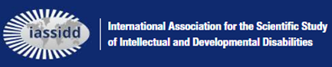

IASSIDD Policy Position Statement
IASSIDD MANDATE

At IASSIDD, every activity, communication, and advocacy effort is firmly anchored in our mission: to advance knowledge, research, and practice in genuine partnership with people with intellectual and developmental disabilities. We recognise that advocacy is essential to promoting the rights and well-being of people with intellectual and developmental disabilities, and we are committed to engaging in issue advocacy, public education, and policy analysis—always when these actions are directly aligned with our mission and grounded in robust research and evidence.
Our advocacy and communication are conducted in a non-partisan, non-political context. As a charitable nonprofit registered in the USA* with a truly global membership, we are dedicated to acknowledging and respecting the cultural, political, and socioeconomic diversity that characterises our international community. Guided by evidence and research, IASSIDD does not support or oppose any political party, candidate, government, or ideology.
We fully respect that our members may hold and express personal political views in their individual capacities. However, it is essential that these personal views are clearly distinguished from official IASSIDD positions. We are committed to upholding this mandate through clear policies, ongoing training, and regular review of our practices.
* As required by Section 509(c)(3) of the US Internal Revenue Code, IASSIDD is legally prohibited from engaging in partisan political activity
Statement approved by IASSIDD Board on
Date 28 Jan 2026

